Student’s name | …………………………………………………….…… | Grade | 2
Subject | Computer | Week No. | 11
Lesson Title | Edit Video | Unit
Worksheet No. ( 11 )

Question A:

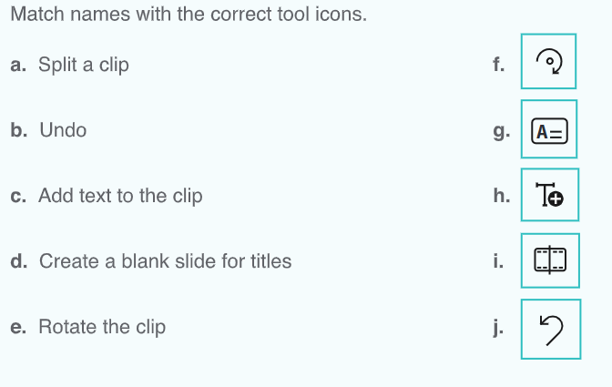
Good Luck

